Paper main title (formatting style: Heading 1; GRF paper -- main title: Cambria, font size 18, indent left 4.5)
Paper sub-title (formatting style: GRF paper subtitle: Cambria, font size 14, indent left 4.5)
Paper author(s) (formatting style: GRF paper author(s): Cambria, font size 11, italic, indent left 4.5)
Authors’ affiliation (formatting style: GRF paper author affiliation: Cambria, font size 10, italic, indent left 4.5)

Abstract (formatting style: Heading 2; GRF paper -- section heading; Cambria, font size 14, italic, bold, justified)

300-500 words uses the style ‘NORMAL’

Paper section heading (formatting style: Heading 2; GRF paper -- section heading; Cambria, font size 14, italic, bold, justified)
Text (Normal; Cambria, font size 11, justified) text text text text text text text text text text text text text text text text text text text text text text text text text text text text text text text text text text text text text text text text text text text text text text text text text text text text text text text.

Paper sub-section heading (formatting style: Heading 3; GRF paper -- sub-section; Cambria, font size 11, bold, justified)

Paper sub-sub-section heading (formatting style: Heading 4; GRF paper -- sub-sub section heading; Cambria, font size 11, italic, justified)
Text (Normal) text text text text text text text text text text text text text text text text text text text text text text text text text text text text text text text text text text text text text text text text text text text text text text text text text text text text text text text text text text text text text text.
Bullet list:
- use formatting style “GRF paper bullet list”.
Text (Normal) text text text text text text text text text text text text text text text text text text text text text text text text text text text text text text text text text text text text text text text text text text text text text text text text text text text text text text text text text text text text text text text text text text text text text text text text text text text text text text text text text text text text text text text text text text text text text text text text text text text text text text text text text text text text text text text text text text text text text.
Text (Normal) text text text text text text text text text text text text text text text text text text text text text text text text text text text text text text text text text text text text text text text text text text text text text text text text text text text text text text text text text text text text text text text text text text text text text text text text.
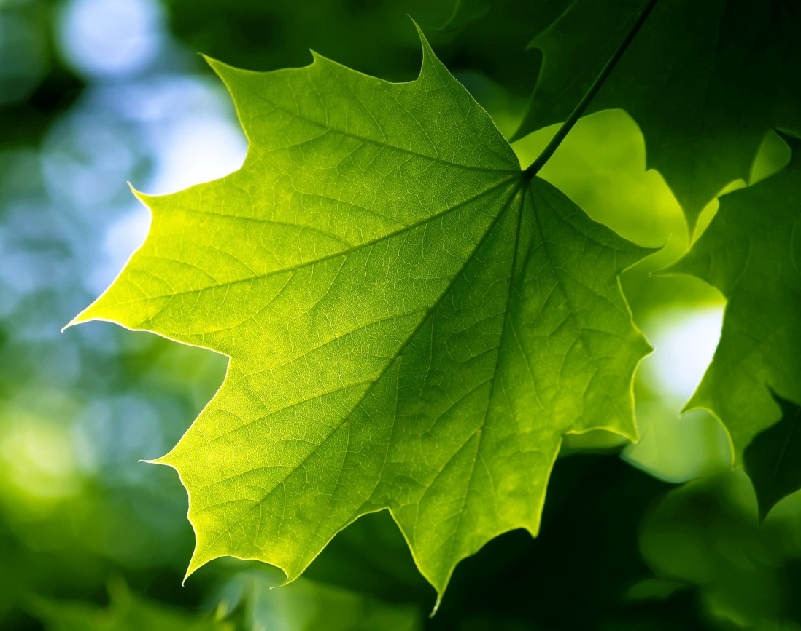
Figure x: Caption centre, below (GRF paper figure title; Cambria, font size 10, italic, centred).
Text (Normal) text text text text text text text text text text text text text text text text text text text text text text text text text text text text text text text text text text text text text text text text.
Table x: Caption above (formatting style: GRF paper table title: Cambria, font size 10, italic, justified)
Lay-out | As | Pleases
Lalalala (Normal)
La
La
La

Text text text text text text text text text text text text text text text text text text text text text text text text text text text text text text text text text text text text text text text text text text text text

Conclusions
Text (Normal) text text text text text text text text text text text text text text text text text text text text text text text text text text text text text text text text text text text text text text text text text text text text text text text text text text text text text text text text text text text text text text.

References (formatting style: Heading 2; GRF paper – section heading; Cambria, font size 14, italic, bold, justified)
Use any reference style, e.g. Author name(s) (year). Title. Publisher.
Lay-out with formatting style “GRF paper reference list” (Cambria, font size 11, aligned left, indent ‘hanging, 1cm’)

Please lay-out footnotes in formatting style “GRF paper footnote”: Cambria, font size 9, justified, indent ‘hanging, 0.4cm’

